

**ECEN 5053-003 Homework Assignment**

Course Name: Embedding Sensors and Actuators

Corresponding Module: C3M2

Week Number: 10

Module Name: Force Sensors

Note: Correct answer is in Blue Font

Submitted by: Poorn Mehta

Part 1: Each question is worth 6.7 points.

1. Answer the following questions about strain gauge terminology:

A.1 What is the Gage Factor (GF)?

Answer: **Gage Factor is also known as the strain sensitivity of a strain gauge, which effectively gives the amount of resistance changed, based on the amount of strain induced.**

If a wire is held under tension, it gets slightly longer and its cross-sectional area is reduced. This changes its resistance (R) in proportion to the strain sensitivity (S) of the wire's resistance. When a strain is introduced, the strain sensitivity, which is also called the gage factor (GF), is given by [**[1]**](https://www.omega.com/literature/transactions/volume3/strain.html) :



A.2 What is the Temperature Coefficient of Resistance (TCR)?

Answer: **A resistor's Temperature Coefficient of Resistance (TCR) tells how much its value changes as its temperature changes**. It is usually expressed in ppm/°C units [**[2]**](https://riedon.com/technical/understanding-temperature/) .

A.3 What is the Temperature Coefficient of Gauge Factor (TCGF)?

Answer: **Gage factor is dependent on the temperature, and this characteristic is known as temperature coefficient of gage factor. For strain gauge, it is expressed in %/K units.** Tts distorting effect on the measurement result is usually relatively small and is therefore mostly ignored. However, a computational compensation (for the temperature measurement) is also feasible [**[3]**](https://www.hbm.com/en/6725/article-temperature-compensation-of-strain-gauges/) .

A.4 What is apparent strain?

Answer: **Apparent strain is any change in gage resistance that is not caused by the strain on the force element. Apparent strain is the result of the interaction of the thermal coefficient of the strain gage and the difference in expansion between the gage and the test specimen.** In addition to the temperature effects, apparent strain also can change because of aging and instability of the metal and the bonding agent [**[4]**](https://www.omega.com/literature/transactions/volume3/strain3.html) .

A.5 What is bonded resistance?

Answer: **Bonded resistance is basically an inaccuracy. It is apparent strain induced in the gauge by bonding the gauge with**

**adhesive at a very high temperature, and then using it at room**

**temperature.**

A.6 What is null compensation?

Answer: Usually, the output of the strain gauge is not zero when the input strain is zero. This is known as null error and should be compensated using proper methods. Thus, **balancing the bridge so that the output voltage is zero when there is no strain on the sensor – is called null compensation** [**[5]**](https://www.engr.uidaho.edu/thompson/courses/ME330/lecture/straingage.html) .

A.7 High resistivity gauges exhibit nonlinearity due to a very large TCR, so that even if adjacent gauges in a four-wire bridge are strained equally and opposite, their resistance changes differently. What can you do differently in the excitation of the bridge to combat this effect?

Answer: Since the TCR is high, the excitation should be chosen in such a way that the **self-heating is prevented. For this reason, the bridge should be excited using constant current source – which will indirectly compensate for temperature.**

B. A solid steel beam of width .06 meters and height .08 meters has an axial force placed on it of 250,000 Newtons. If the Modulus of Elasticity is 220 Gigapascals, what is the lateral strain εy? (Type in a five-decimal number)

Answer: **6.74716 x 10-5**

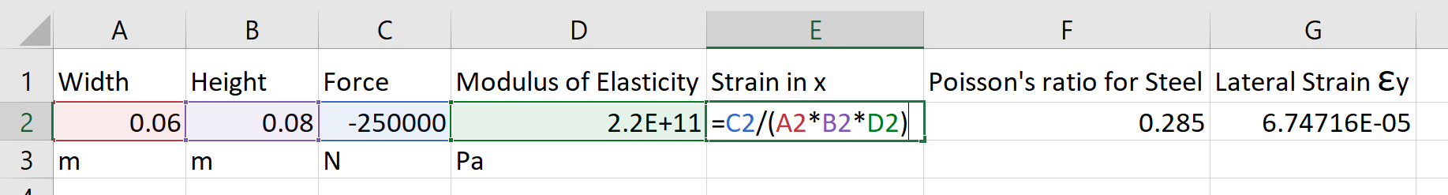

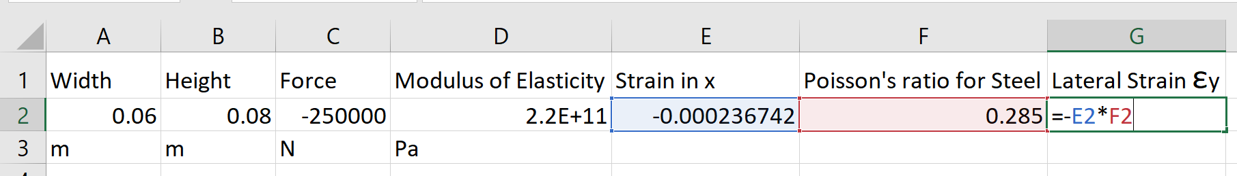

1. A cantilever beam has stress created by a downward point load F. The beam is instrumented with 4 strain gauges arranged in a Wheatstone bridge, where the two tensile gauges on the top have equal resistance to each other, and the two compressive gauges on the bottom have equal resistance to each other.

Other dimensions and parameters are given by:

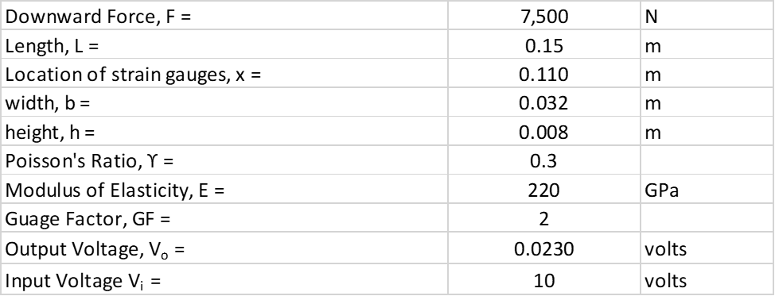

What is the absolute value of the axial strain εx based on beam theory? What is the absolute value of the axial strain εxg based on the voltage output of the strain gauge bridge?

Answer: **0.00119 from Theory, 0.00115 from Bridge**

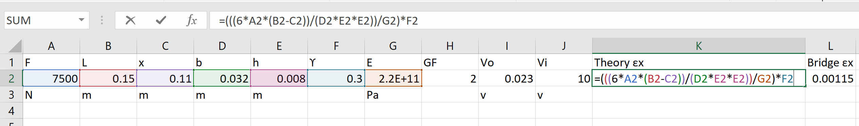

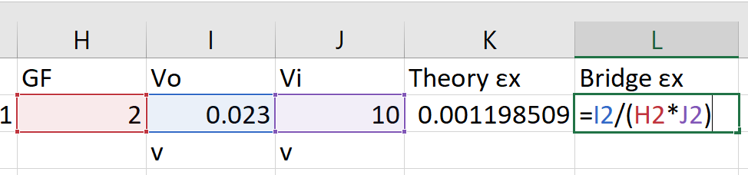

1. A strain gauge is used at a temperature far above where it is calibrated.

The parameters of operation are given by:



Ignoring the effects of TCR, what strains are measured at the nominal and elevated temperatures? What is the percentage error in your measurement?

Answer: **0.0045 Nominal, 0.004462 Elevated, 0.855125% Error**

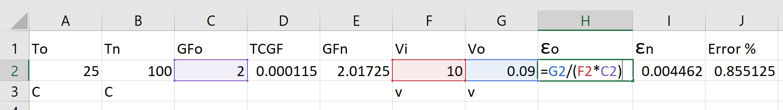

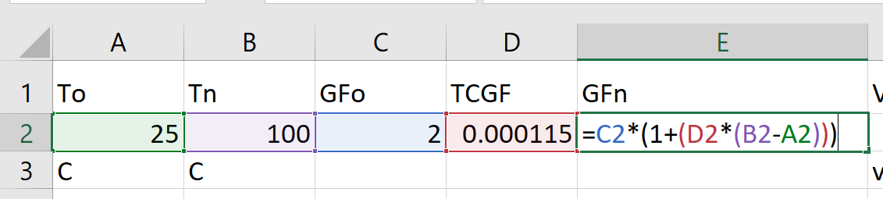

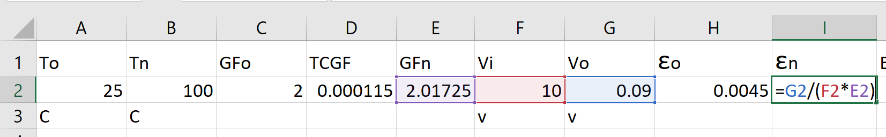

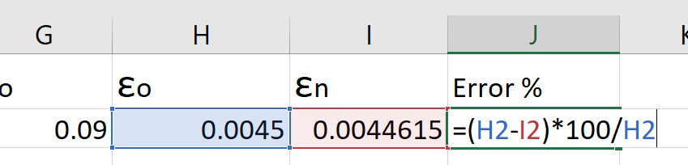

1. The TCR of a strain gauge can be negated by wiring 4 strain gauges into a 4-wire Wheatstone bridge where two gauges are in compression, two in tension, and the nominal resistances at the calibrated temperatures are identical. Perform a calculation to prove this empirically, using the information below. Calculate the strain in the gauge at the nominal and elevated temperatures, and show that you get the same number.



Answer: **Both – 0.003**

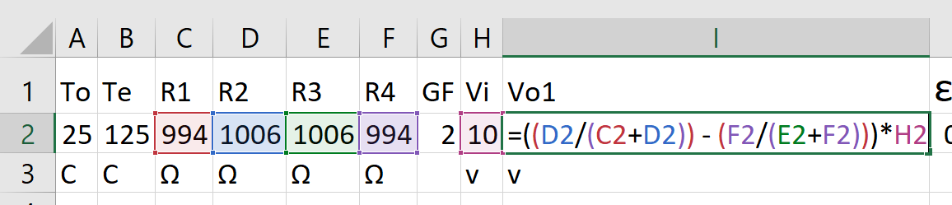

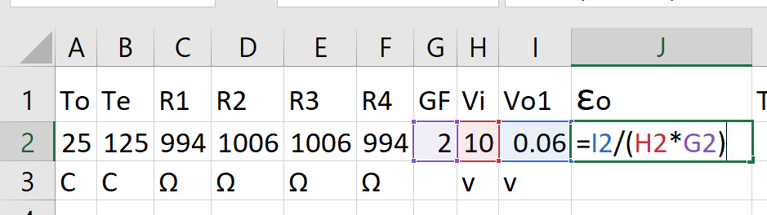

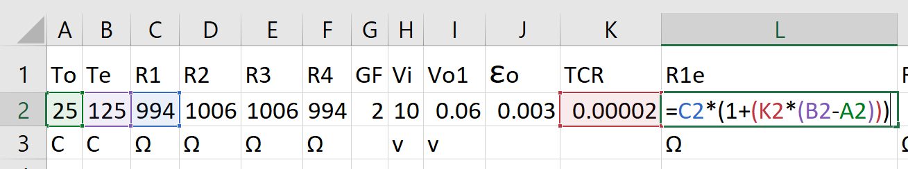

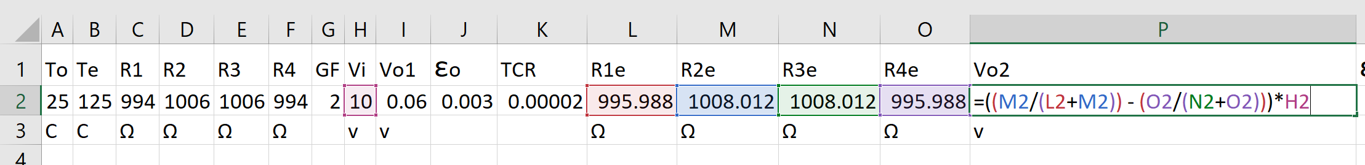

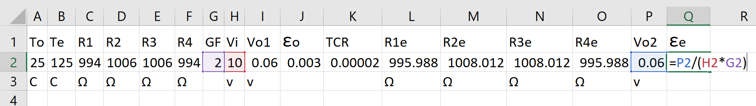

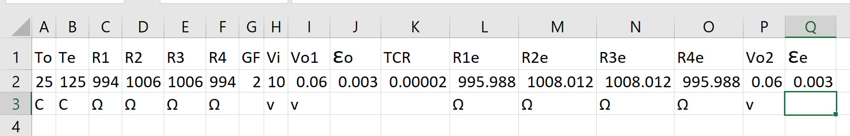

1. A strain gauge with Constantan wires is bonded to a ferrite steel structure at the nominal temperature. When the structure heats up an apparent strain is output by the gauge. What is the value of the apparent strain for this situation below?



Answer: **0.000719**

Reference for thermal expansion coefficient values: [**[6]**](http://www.goodfellow.com/E/Constantan-Resistance-Alloy.html)[**[7]**](http://www.owlnet.rice.edu/~msci301/ThermalExpansion.pdf)

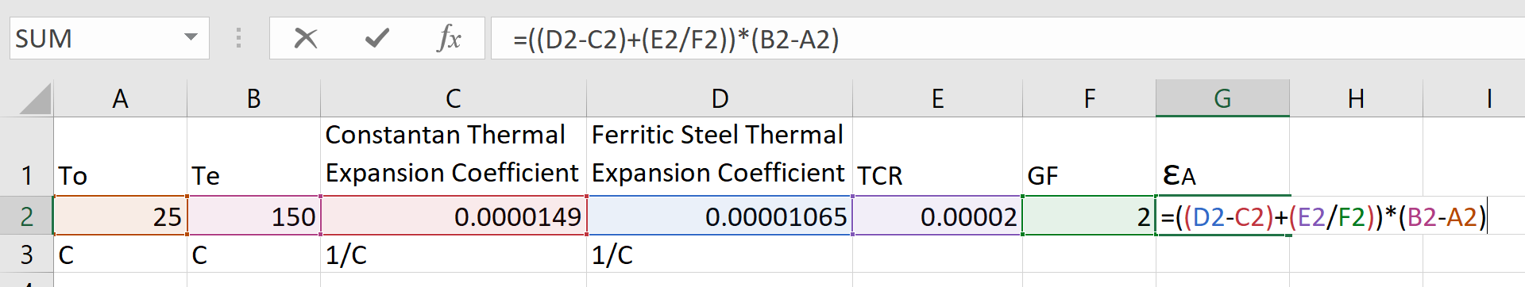

1. Four identical strain gauges with Constantan wires are bonded to a titanium aircraft component at an elevated temperature, and then allowed to cool back to the nominal temperature. The gauges are arranged in the Wheatstone bridge circuit below. R2 and R3 are in tension, and R1 and R4 are in compression. This topology negates any effect due to the TCR of the gauge, and you get the given change of resistance under strain. However, there will still be an error in your strain measurement due to bonded resistance.

When the gauge is used at the nominal temperature, what is the value of the bonded resistance for this situation below? What strain does the gauge measure, ignoring the effects of bonded resistance? What strain does the gauge measure, ***including*** the effects of bonded resistance? What is the resulting % error in your measurement?

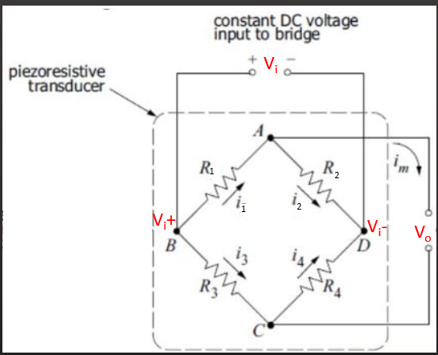



Answer: **1002.921 RB, 0.01 without Bonded Resistance, 0.009971 with Bonded Resistance, 0.2912% Error**

Reference: [**[8]**](https://www.amesweb.info/Materials/Thermal_Expansion_Coefficient_of_Titanium.aspx)

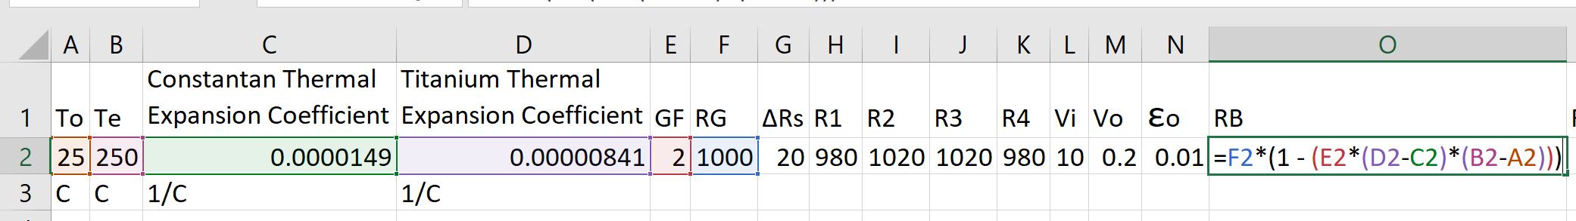

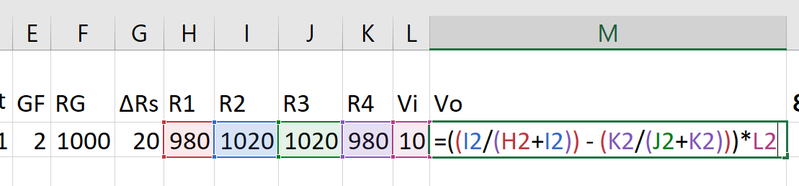

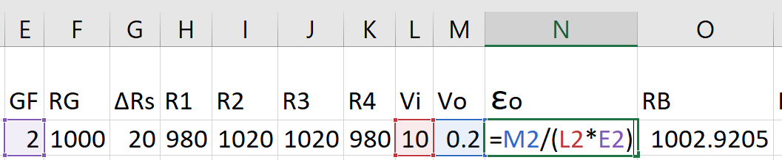

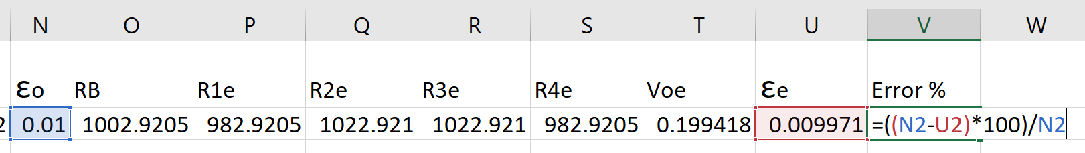

1. Derive the General Formula for Strain Gauges in a Full Bridge, shown in the lower right corner of this slide below.

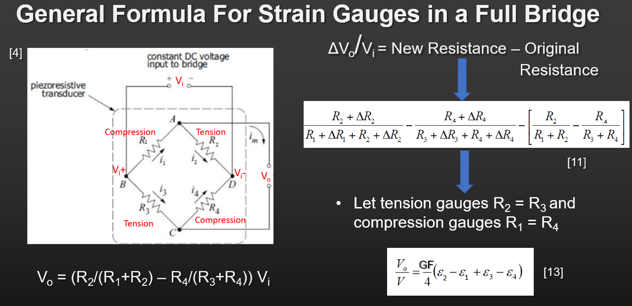

Answer:

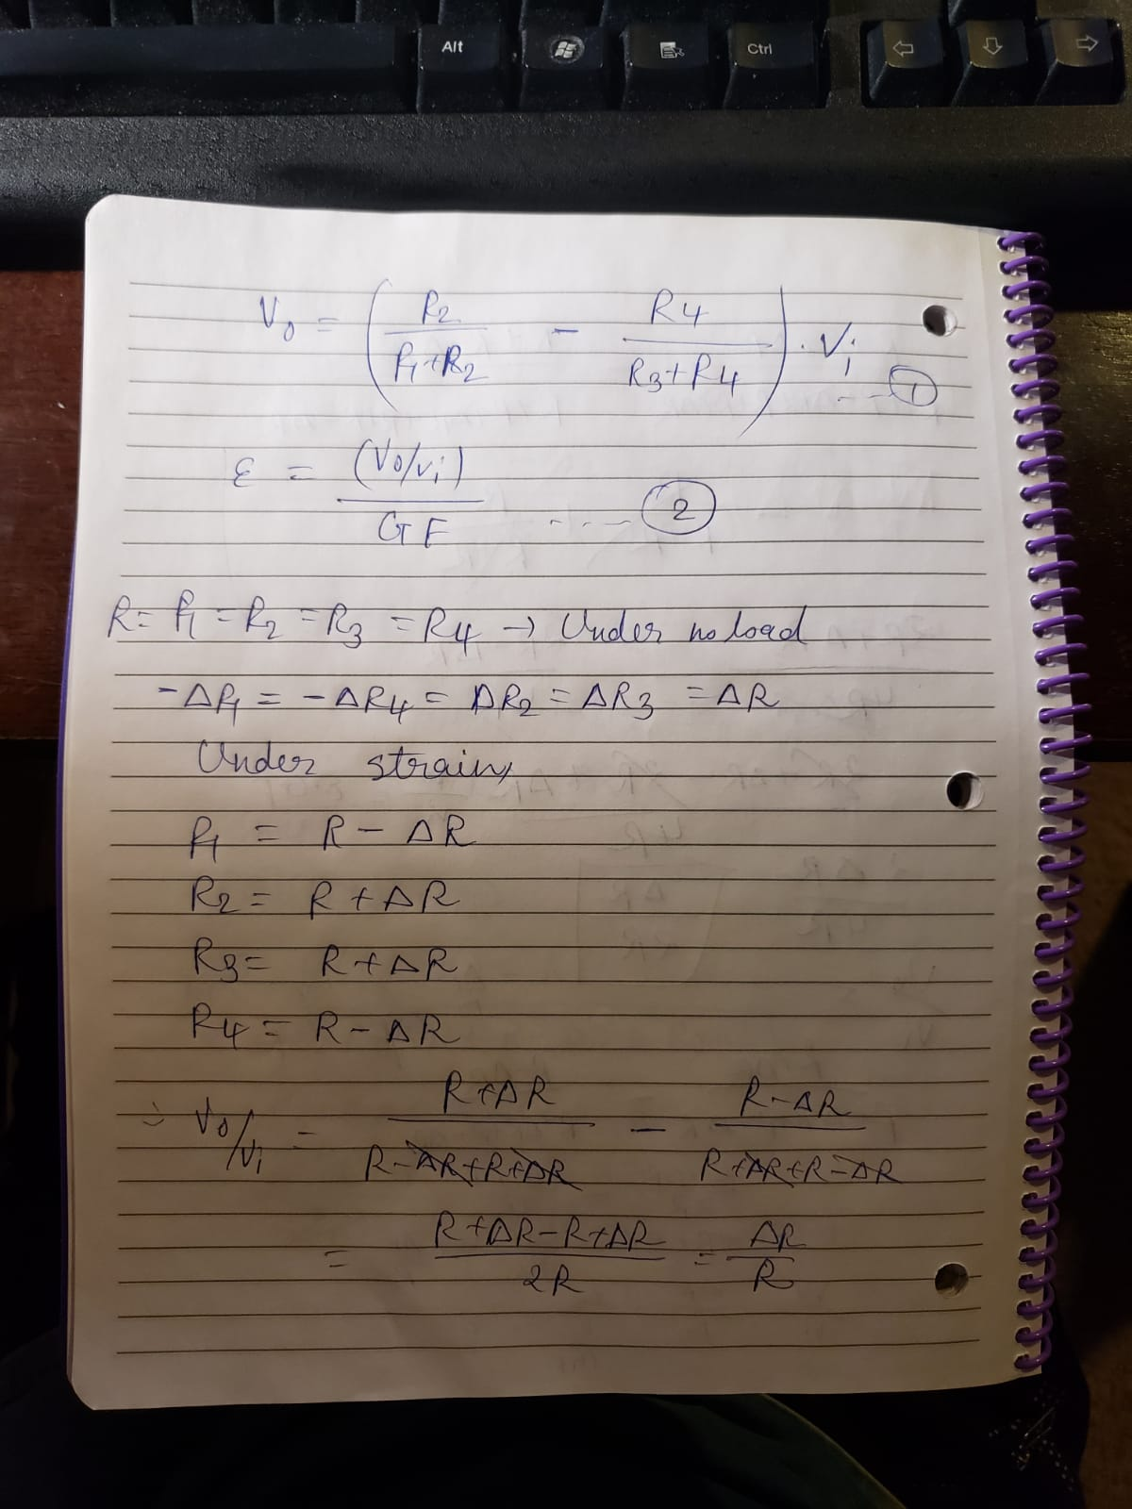

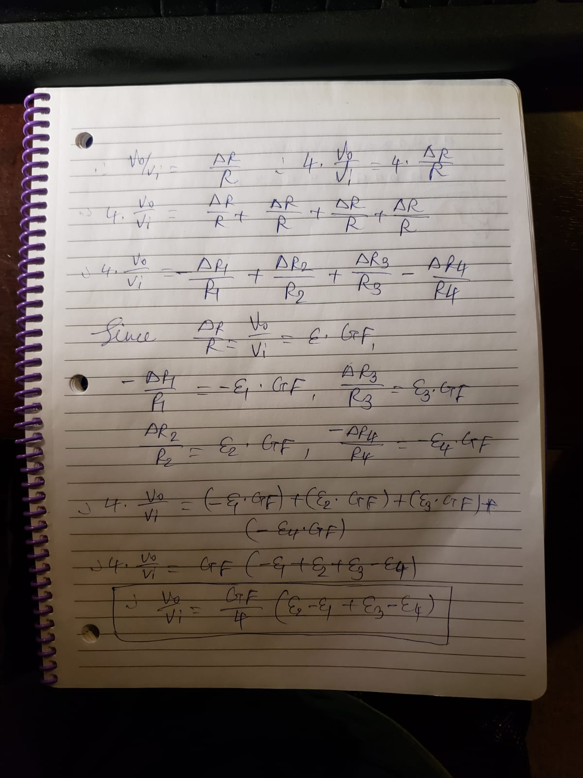

1. Which type of load cell would you specify in each of these situations, how would you use this load cell, and why did you choose it?

I1. You have a minimum amount of clearance in your machine to fit the load cell and you plan on mounting the load cell with a series of bolts directly to the frame of your machine. You put the object to be weighed on a steel platform, which sits on top of the load cell.

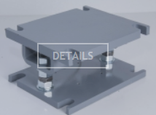

Answer: **Low Profile (Pancake) Load Cell**

Since pancake load cells **can be designed to be fitted with screws**, it will be very easy to use them for the given application. Also, they are **efficient, reliable, and highly accurate**. Moreover, they’re **suitable for weighting application** and thus, it is the best match for the given application [**[9]**](https://www.tecsis.us/force-load/pancake-load-cells.html) [**[10]**](https://www.load-cells.org/pancake-load-cells/).

I2. You are picking up a very heavy container with a helicopter using a set of thick steel cables. The load cell measures the tension in one cable section. If the tension gets too high, you know that the cable may break. You send a signal to the helicopter to immediately place the container back on the ground.

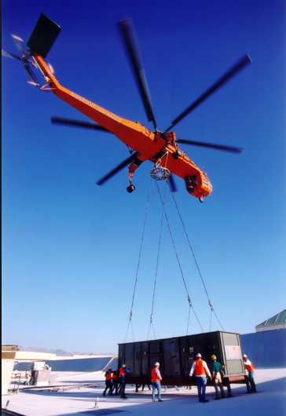

Answer: **S-Beam Load Cell**

Since the S-Beam load cells have a **threaded hole at each end, it’ll be very convenient to tie up the steel cables** with these load cells. Also, they’re **widely used in heavy load measurement** – such as tank weight measurement – which points to the fact that a group of such cells can definitely handle the given application without much trouble. Four of these load cells **should be used in a wheatstone bridge** [**[11]**](https://www.load-cells.org/s-beam-load-cell/) .

I3. You are designing a cheap electronic bathroom scale, for sale at retail of between $20 and $40. It would look like the one below.

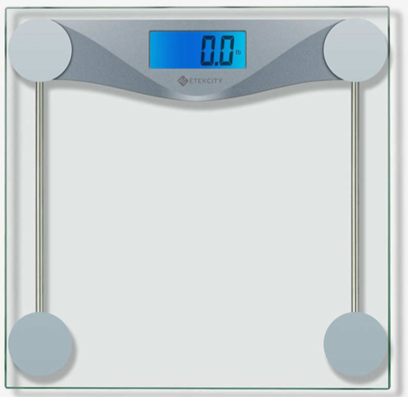

Answer: **Half Bridge Micro Load Cell (or Strain Gauge)**

**Four of the single strain gauge load cells can be used – one in each corner, in a quarter bridge configuration**. It will be used with necessary mechanical arrangement to convert the force due to weight of an object into a strain that can be measured by the load cell. These load cells are ideal for the given application because they’re **quite cheap and reliable** at the same time [**[12]**](https://www.alibaba.com/product-detail/GML623A-4pcs-strain-gauge-half-bridge_60434858793.html?spm=a2700.7724838.2017115.51.62415a1awfWGyl&s=p) .

1. How are the load cells wired in our video for tearing down a bathroom scale (C3M2V4.mp4)? What compensation method is left out of this wiring method, and why could the manufacturer still get an accurate reading anyway?

Answer: **Quarter Bridge**

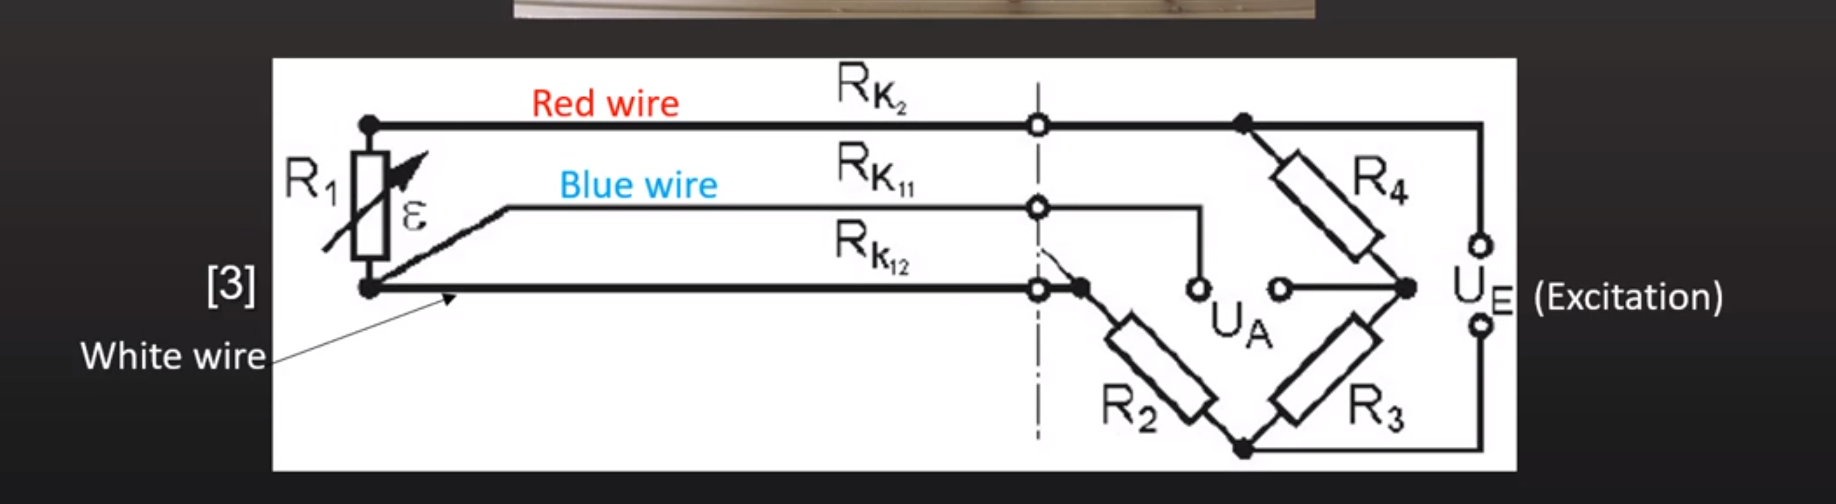

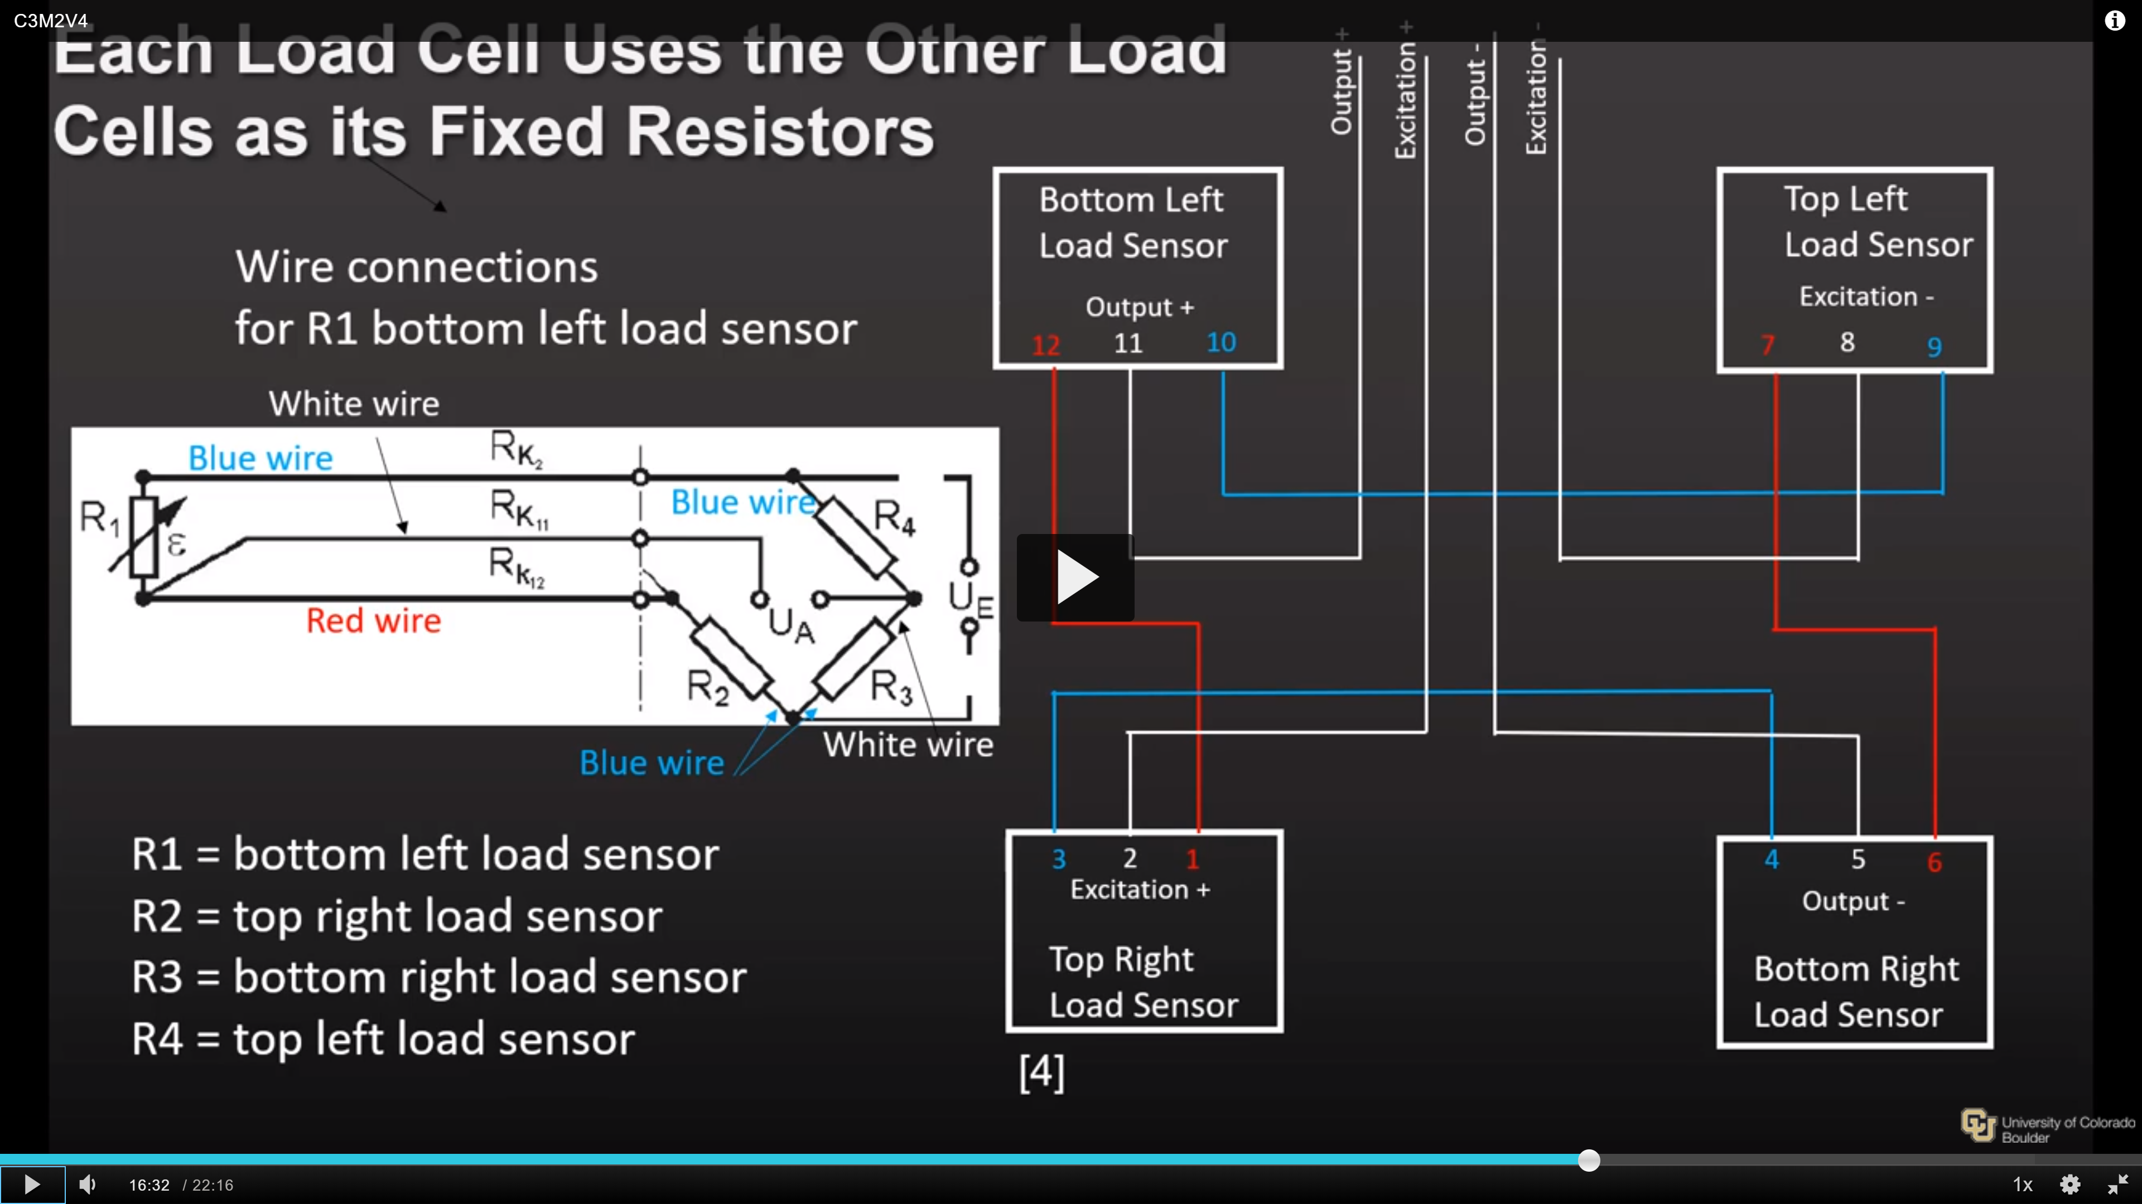

**Temperature compensation is left out and it doesn’t matter because usually, the scale is at the nominal temperature all time.**

1. Why do the load cells used in our video for tearing down a bathroom scale (C3M2V4.mp4) have no fixed resistors, even though you normally need them to get a reading for the type of bridge circuit used?

Answer: **Load cells at nominal temperature – and after the weight is stabilized after a couple of seconds – can work as fixed resistors. So, each load cell is using the others as a fixed resistor, which works quite well.**

1. These questions refer to the Cypress Inc. reference [AN64846 Getting Started with CapSense.pdf](http://www.cypress.com/file/41076/download).

L1. Why does your capacitive touch circuit need a hatched ground plane?

Answer: **To avoid increment in parasitic capacitance.**

Usually solid grounds are preferred as the reduce the RF noise but if they’re near the CapSense sensors, or traces connecting these sensors to the PSoC pins, then it will result in increased parasitic capacitance of the sensors. This will result in reduced sensitivity, which leads to the use of hatched ground plane.

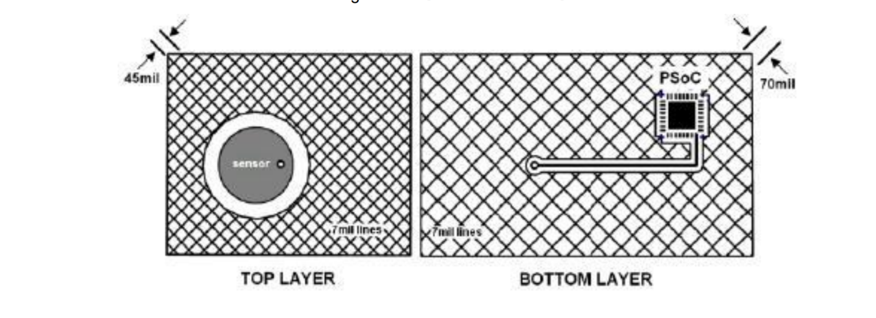

L2. How does Self-Capacitance work?

Answer: Self-capacitance uses a single pin and **measures the capacitance between that pin and ground**. A self-capacitance sensing system operates by driving current on a pin connected to a sensor and measuring the voltage. **When the finger is not placed on the overlay, the measure capacitance is equal to parasitic capacitance. But when the finger is placed, a simple parallel plate capacitor is formed (with the sensor pad, through the overlay). This will result in increased capacitance – therefore, making it quite easy to detect the touch.**

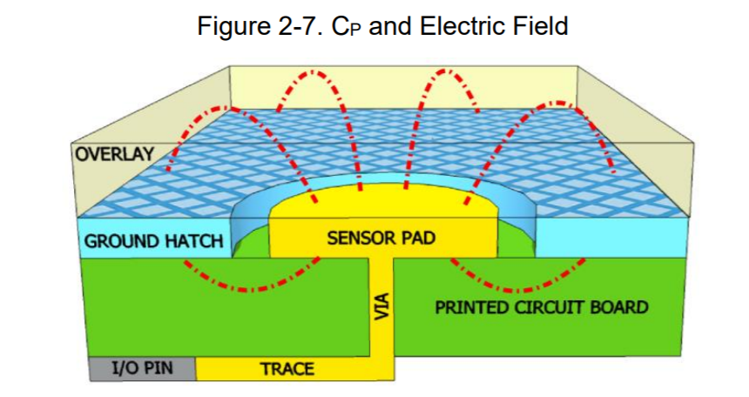

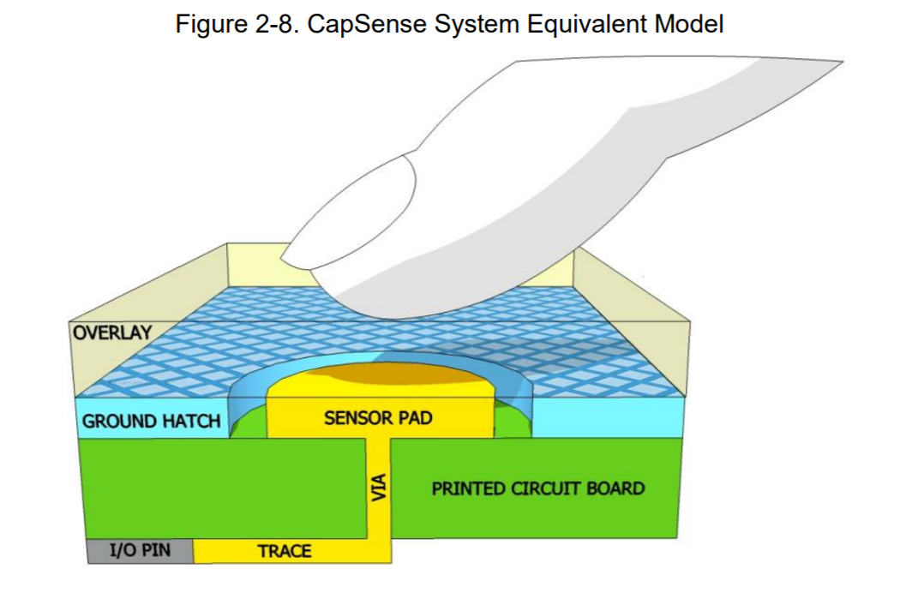

L3. How does Mutual Capacitance work?

Answer: Mutual capacitance is **the capacitance between two electrodes**. **One electrode is supplied with digital voltage and the other one is measured for the amount of charge received. The charge is proportional to the capacitance between these two electrodes. Therefore, if a finger is placed, the capacitance will be reduced significantly which will be noticed by the microcontroller.**

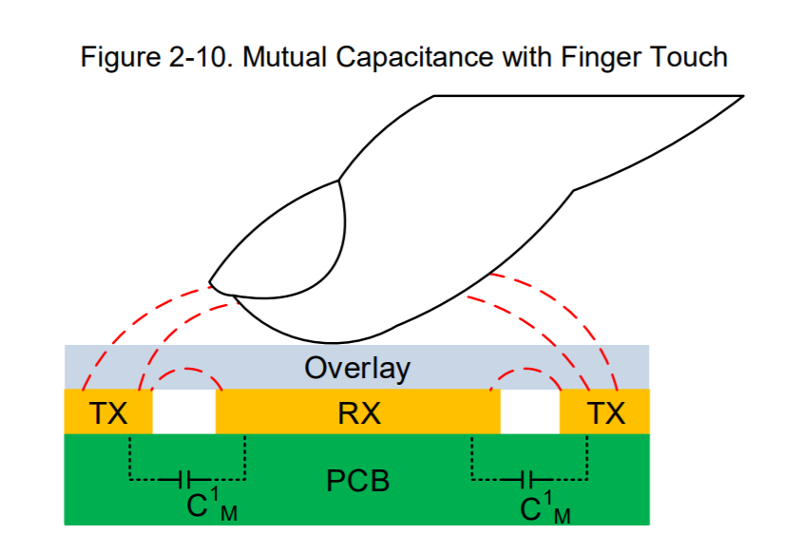

L4. What is the raw count of the CapSense hardware?

Answer: **The raw count of the CapSense hardware is the digital representation of the capacitance. It is proportional to the actual capacitance value.**

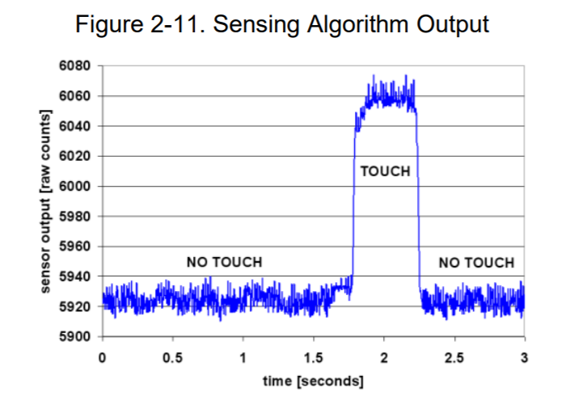

L5. How is proximity sensing done using CapSense hardware? How is such a system constructed?

Answer: **A proximity sensor is like any other sensor but designed with very minimum ground near the sensor and tuned for maximum sensitivity. Also. for detecting the target object, the Signal-to-Noise Ratio (SNR) should be greater than or equal to 5:1.** The design flow chart is shown below:

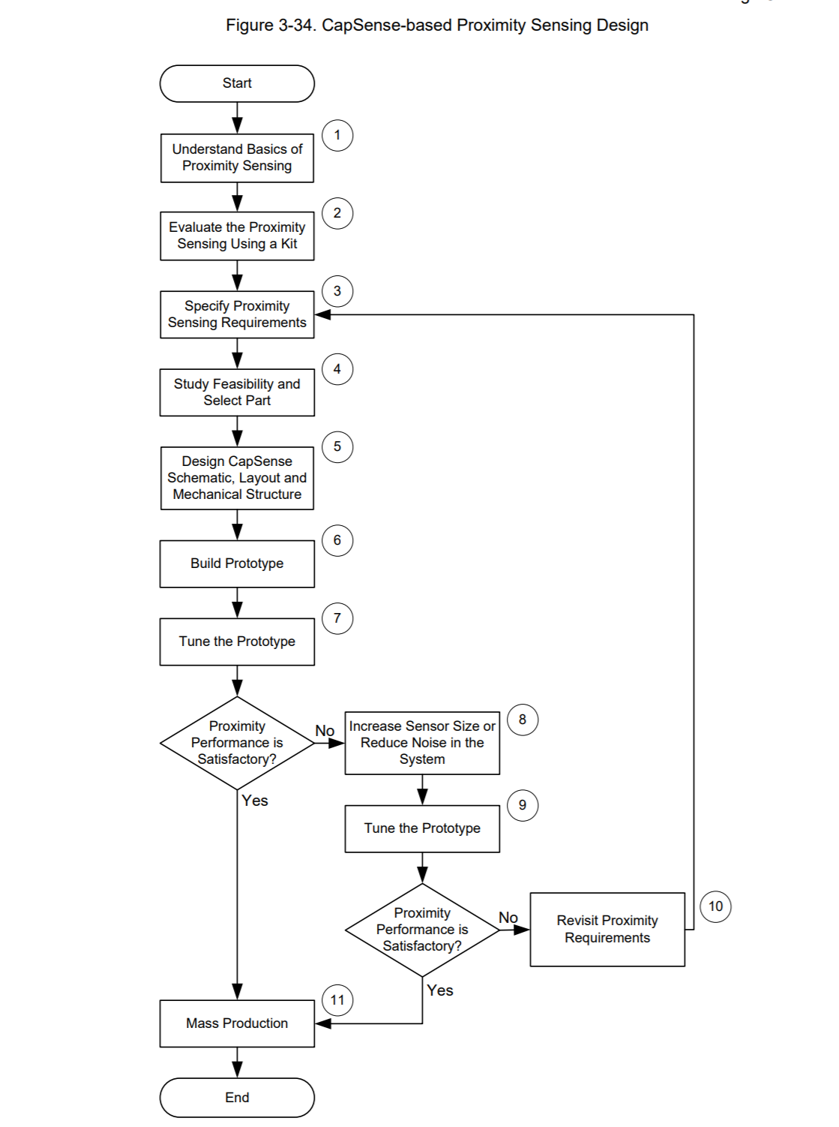

There are many **methods** of constructing a proximity sensor:

1. **Button**:
   1. Basically, a button sensor which is **tuned for high sensitivity**.
   2. Since the proximity sensing distance is directly proportional to the sensor area, this type of proximity sensor has **very less sensitive distance.**

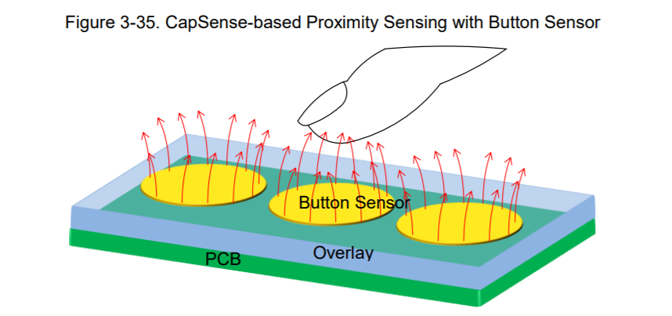

1. **PCB Trace**:
   1. **Parasitic capacitance is less**.
   2. **More sensing distance** since area is larger.
   3. **Either a straight line (bar) or loop configuration**.
   4. **Appropriate for mass production**.

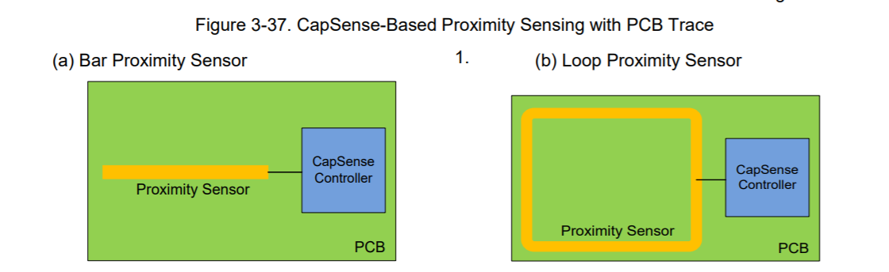

1. **Wire**:
   1. **Higher sensitive distance**
   2. **Complex and costly**
   3. **Not suitable for mass production**
2. **Sensor Ganging**:
   1. **Connecting multiple sensors (such as button, PCB trace etc.) as one sensor.**
   2. **It increases effective sensor area and thus proximity sensing range however, the combined parasitic capacitance must not cross 45pF**.

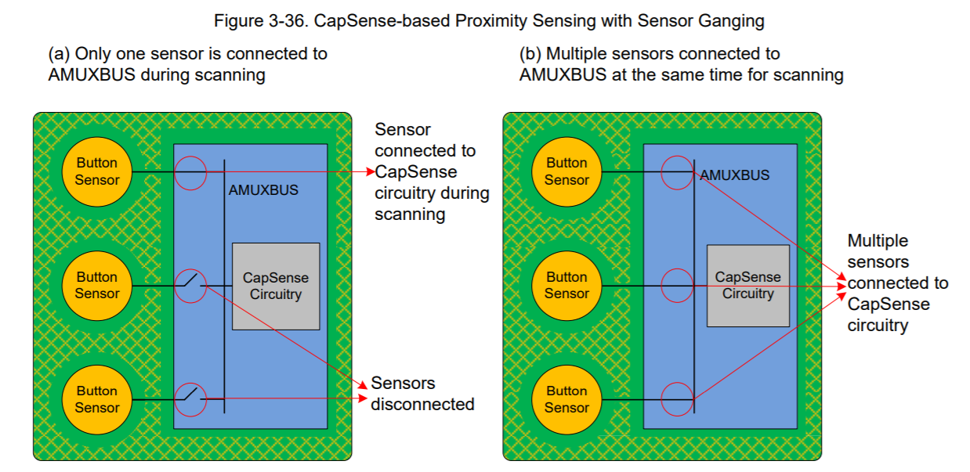

1. Go to Google Patents ([www.patents.google.com](http://www.patents.google.com)) and download US patent 8,040,142. Read the patent and answer the following questions:



M.1 How does the prior art circuit of Figure 1B work to sense a change in capacitance? What are the limitations of this method if you try to use it to sense a change in capacitance due to a finger touch?

Answer: FIG. 1B illustrates capacitance sensing technique using a charge transfer mechanism. It houses a conventional capacitance measurement circuit 101 including three switches 105 with control terminals φ0, φ1, and φ2, and summing capacitor 110 having a capacitance CSUM, and an analog to digital converter 115.

Capacitance measurement circuit 101 may be used to sense changes in a DUT capacitor 120 having a changing capacitance CDUT. During operation, capacitance measurement circuit 101 operates as follows to sense capacitance changes on DUT capacitor 120.

**Working:** First, **summing capacitor 110 is discharged** to a ground potential by asserting control terminal φ0 to open circuit switch SW0 and by asserting control terminal φ1 to close circuit switch SW1. Once discharged to ground, **integrating capacitor 110 is disconnected from ground** by asserting φ1 to open switch SW1. Then, **DUT capacitor 120 is charged to the supply voltage VS** by asserting φ0 to open circuit switch SW0 and asserting φ2 to close circuit switch SW2. Once DUT capacitor 120 charges to the supply voltage VS, the **charge on DUT capacitor 120 is transferred onto summing capacitor 110 and distributed between the two capacitors**. Charge transfer occurs by asserting φ1 and φ2 to open circuit switches SW1 and SW2, respectively, and asserting φ0 to close circuit switch SW0.

**The above stages of charging DUT capacitor 120 and transferring the charge onto summing capacitor 110 are repeated a fixed number of times causing the voltages of nodes N1 and N2 to ramp with time** as illustrated in line graphs 130 and 135, respectively. **After a fixed number of consecutive charging stages and charge transferring stages, ADC converter 115 samples the final voltage on node N2. The capacitance CDUT is determined based on the output of ADC converter 115 and is proportional to the voltage at node N2 after the final charge transfer stage**.

**Limitations:** Because the capacitance deviation of a capacitance sense switch due to a finger press is small compared to the underlying capacitance of the switch itself, the above capacitance sensing technique can be **susceptible to external noise, interference, or other environmental factors**. For example, parasitic capacitances may couple to the user interface, electromagnetic interference may disrupt capacitance measurements and control signals, deviations in operating temperature can cause thermal expansions and dielectric variations that affect capacitance measurements, user error can result in malfunctions, and so forth. These environmental factors can often result in disruptive capacitance deviations that are larger than the capacitance changes induced by a finger interaction with the capacitance sense interface.

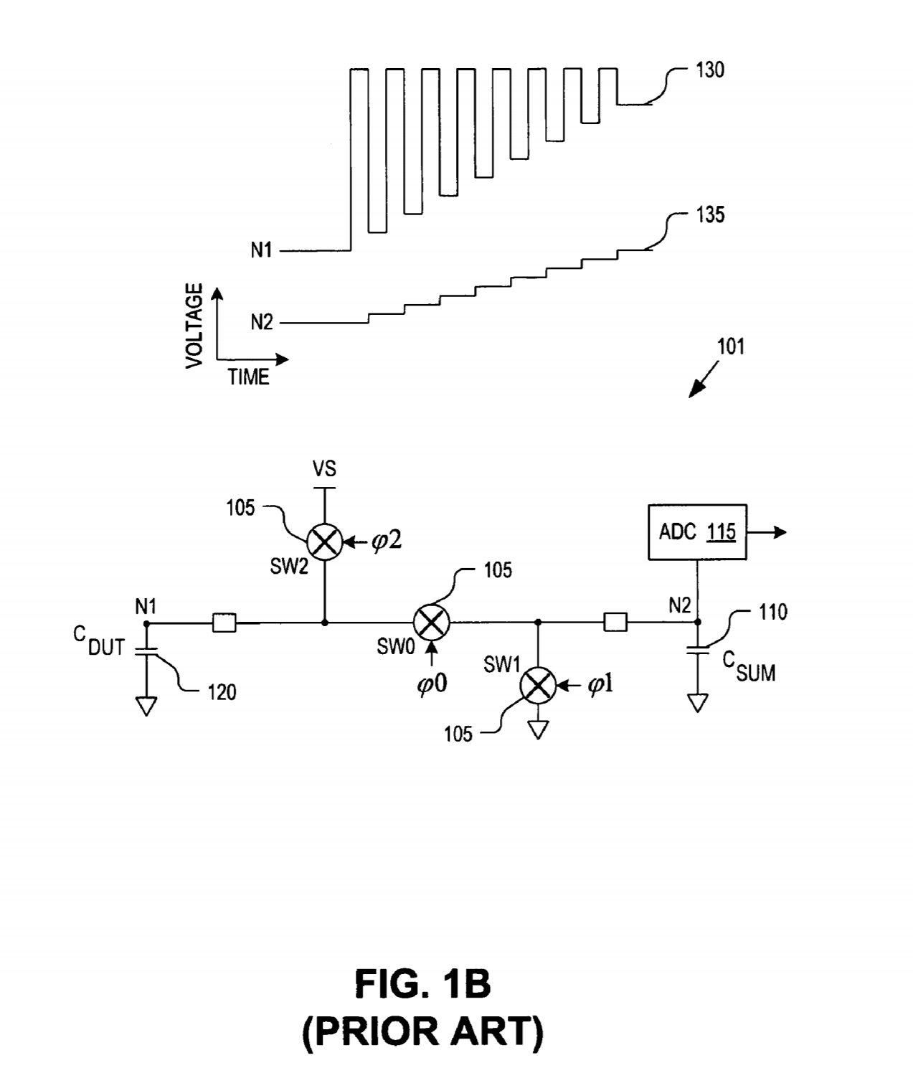

M.2 What can you tell from figure 4 capacitance values about the capacitances of the five CAP sensors represented by the curves S0, S1, S2, S3, and S4?

Answer: Chart 400 plots capacitance values for CAP sensors 325 versus time. The capacitance values plotted along the y-axis of chart 400 are values determined by capacitance measurement circuitry 305 that are representative of a measured capacitance of CAP sensors 325.

In one embodiment, the capacitance values are clock cycle counts gated by relaxation oscillator circuitry included within capacitance measurement circuitry 305. In one embodiment, the capacitance values are the output of an analog-to-digital converter.

Each trace S0, S1, S2, S3, S4 represents a measured capacitance value associated with a corresponding one of CAP sensors 325. Each CAP sensor 325 is sampled in sequence by capacitance measurement circuitry 305 one time during each scan cycle. Traces S0 to S4 have been staggered vertically for clarity; however, **if CAP sensors 325 are physically identical in size and orientation, traces S0 to S4 may in fact overlap with minor deviations due to localized variations in the capacitances of each CAP sensor 325.**

During operation, the baseline **capacitance** of CAP sensors 325 **may drift due to a variety of environmental factors**, such as temperature changes, dynamically changing parasitic capacitances, localized disturbances, electromagnetic interference (“EMI), or otherwise. **This drift is illustrated by the wandering traces S1 to S4**. Furthermore, chart 400 illustrates a user activation of CAP sensor 325A sometime between the samplings of CAP sensor 325A at time T6 and time T8. In one embodiment, when the measured capacitance value of CAP sensor 325A crosses the activation threshold, the user activetion of CAP sensor 325A is registered or acknowledged by Software or hardware logic coupled to capacitance measurement circuitry 305.

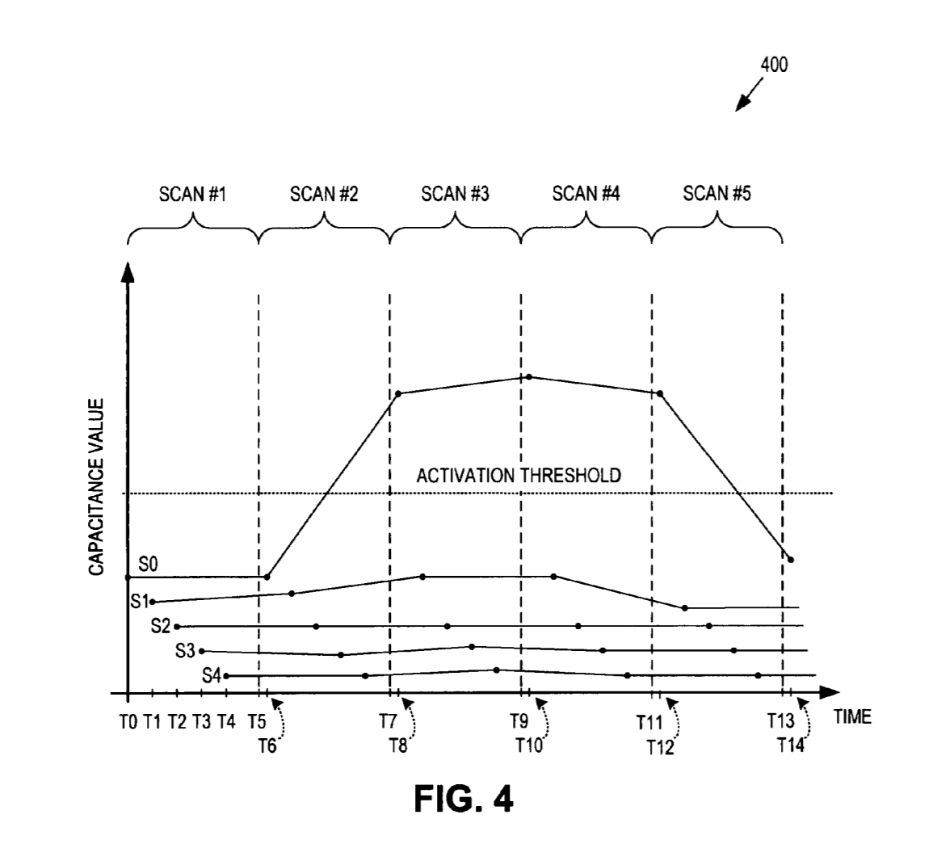

M.3 What is the purpose of the Touch Sense Logic in figure 5?

Answer: FIG. 5 is a functional block diagram illustrating a system 500 for improved capacitive touch sensing, in accordance with an embodiment of the invention. The illustrated embodiment of system 500 includes capacitance sensor circuit 300, touch sense logic 505, application logic 510, and I/O device 515. The illustrated embodiment of touch sense logic 505 includes a startup logic component 520, a baseline logic component 525, a hysteresis logic component 530, an electrostatic discharge component 535, and an interpolation logic component 540.

Touch sense logic 505 may be implemented entirely in software or firmware (e.g., machine readable instructions), entirely in hardware (e.g., application specific integrated circuit, field programmable gate array, etc.), or some combination of both. **Touch sense logic 505 analyzes signal 550 to compensate for various environmental factors** (e.g., temperature drift), **filter noise**, **reject false activation events** (e.g., reject ESD events), **interpolate higher resolution** from capacitance sense interface 315, **and compensate for various other user interactions** with the capacitance sense interface 315. **Touch sense logic 505 analyzes signal 550 to determine whether an actuations of CAP sensors 325 should be registered (acknowledged) as valid touch events or rejected (masked) as false touch events.** While analyzing signal 550, the touch sense logic may implement one or more of the **techniques**: Application logic 510 represents various user applications that may receive input from capacitance sensor circuit 300, use the input to manipulate application data, and generate output for I/O device 515. I/O device 515 may represent any type of I/O device including a display, a network interface card, an audio port, various peripheral devices, and the like.

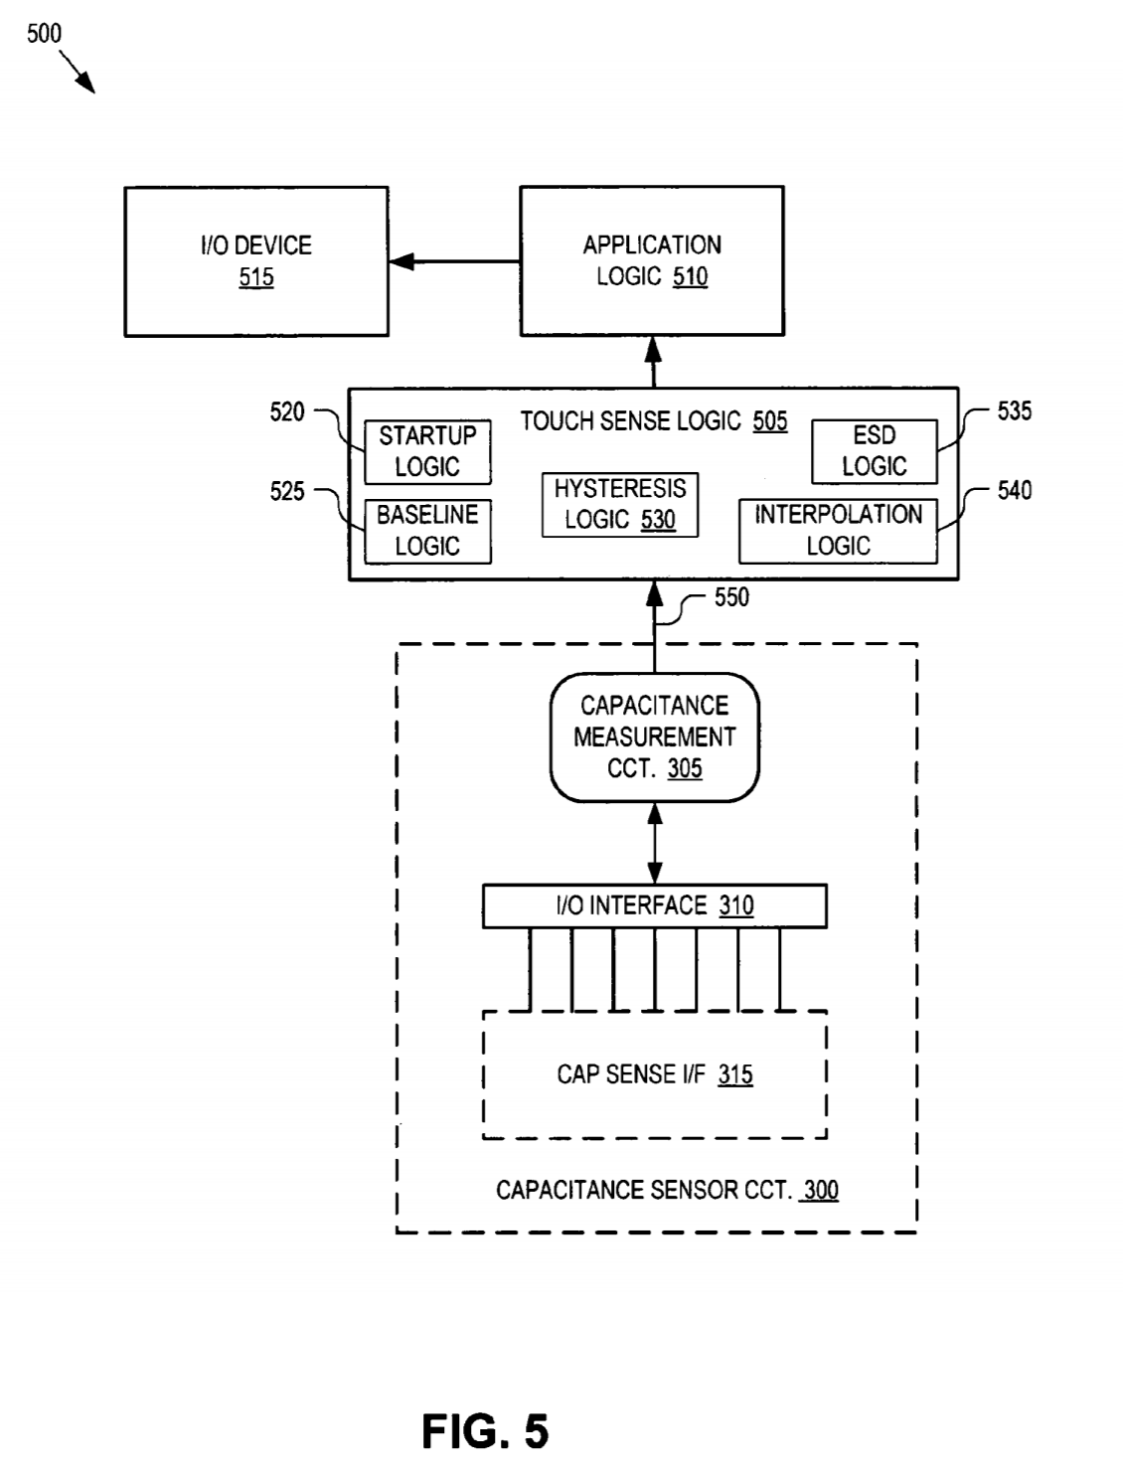

M.4 How does the Baseline Drift Compensation Technique work? How does this system guard against long-term drift of capacitance measurements?

Answer: FIG. 6 is a chart 600 illustrating a baseline drift compensation technique for improved capacitive touch sense operation, in accordance with an embodiment of the invention. In general, capacitance sensor circuit 300 measures a change in capacitance from a deactivated state to an activated state of a selected CAP sensor 325. In one embodiment, baseline logic 525 monitors the difference between the current value of signal 550 and a historical or baseline value. Thresholds for determining whether an activation event has in fact occurred are set related to these historical or baseline values. Measured capacitance values that pass over the activation threshold are considered to be touch events.

**Working:** Accordingly, **it is important to accurately track the baseline capacitance values associated with CAP sensors 325 should they drift over time.** Background (or “parasitic”) capacitance may change slowly as a result of environmental factors (temperature drift, electrostatic charge builds up, etc.). **The activation threshold values should be adjusted to compensate for this background capacitance and other factors. This may be done by monitoring signal 550 in real-time, and updating the baseline capacitance value on a regular basis based on the actual capacitance values measured during each sampling cycle.** **In one embodiment, the baseline capacitance value for each CAP sensor 325 is tracked and updated using a weighted moving average.** For example, the weighted moving average may apply a 0.25 weight to the presently measured capacitance value and a 0.75 weight to the historical baseline capacitance value. Of course, other weights may be applied. In one embodiment, infinite impulse response (“IIR”) filters are used to filter signal 550 in real-time and make computation of the weighted moving average efficient.

As illustrated in FIG. 6, **when an activation is sensed, the baseline capacitance value is held steady so that the elevated values due to the user interaction do not skew the baseline capacitance value calculation. Accordingly, during activations the baseline update algorithm is disabled and the measured capacitance values masked so as to hold the baseline capacitance value steady until the CAP sensor is deactivated.**

**Long Term Drift guarding:** **The rate at which the baseline capacitance values are updated can be set as part of the system design and even updated by users at a later date. The automatic update rate or interval may also be set by the user to compensate for expected environmental variance. Using this, the system is guarded against long term drifts in capacitance measurement.** In the event that environmental changes are too rapid, the automatic update rate can be adjusted at run-time to compensate. In one embodiment, the update interval may be set to every Nth sampling (e.g., N=5), where N can be any positive integer.

The baseline capacitance values for each CAP sensor 325 may be adjusted individually or as part of a sensor group (e.g., sensor groups 340 or 350). Tracking and updating baseline capacitance values for each CAP sensor 325 allows different environmental effects to be compensated in each CAP sensor 325 independently. Alternatively, a group baseline capacitance value compensation enables variations to be averaged over a group of CAP sensors 325. Accordingly, an embodiment of the invention enables convenient group compensation of baseline capacitance values and the update rate to be applied to a group of CAP sensors 325. This may be useful for groups of CAP sensors 325 that are physically adjacent to each other in capacitance sense interface 315.

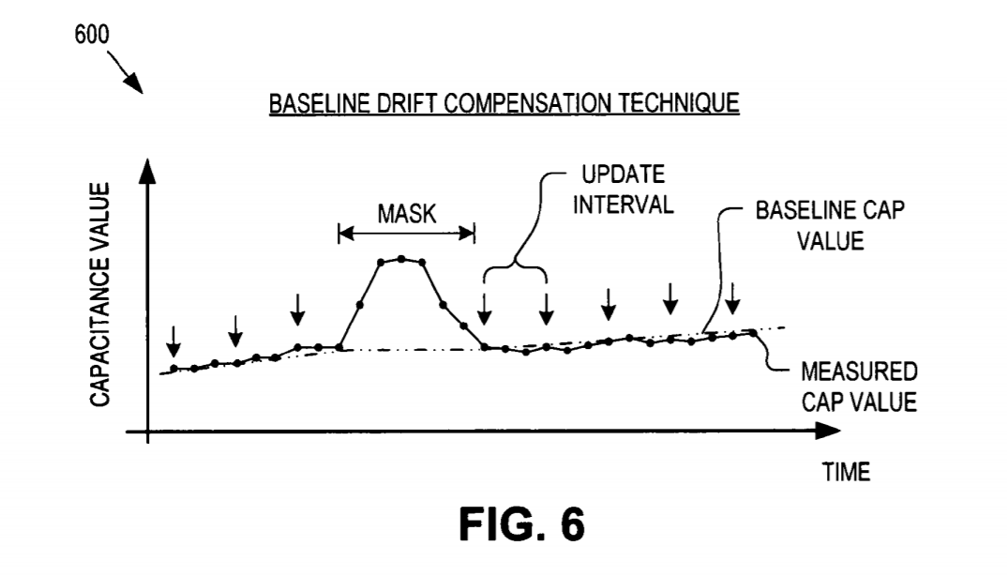

M.5 What is the purpose of the Finger on Startup Detection Technique? Under what condition is this technique implemented in the code?

Answer:

**Purpose:** FIG. 7 is a chart 700 illustrating a finger on startup detection technique for improved capacitive touch sense operation, in accordance with an embodiment of the invention. In one embodiment, the baseline capacitance values discussed above are initialized upon booting or starting system 500. **If during the initialization procedures (e.g., time T0 to T1 in FIG. 7), one or more CAP sensors 325 are actuated by a user (e.g., the user has his finger on one or more CAP sense buttons), it may be necessary to detect this condition and quickly update the startup baseline capacitance values**. After the user removes the activation (time T2 in FIG. 7), the measured capacitance value of signal 550 will change to a negative value below the startup baseline capacitance value. **Simply relying on the baseline logic 525 to slowly track down the startup baseline capacitance value using the weighted moving average can take too long, during which time user interaction with capacitance sense interface 315 will not be recognized. Accordingly, this finger on startup condition should be quickly recognized and compensated.**

**Condition: In one embodiment, the finger on startup condition is determined by startup logic 520, if the measured capacitance values of signal 550 cross a negative finger threshold below the startup baseline capacitance value and remains below it for a predetermined period of time (Tp). If this condition is found to be valid, then the startup baseline capacitance value is immediately updated by averaging the capacitance values measured after signal 550 dropped below the negative finger threshold**. In one embodiment, the predetermined period of time Tp is a fixed number of sampling cycles (e.g., five sampling cycles).

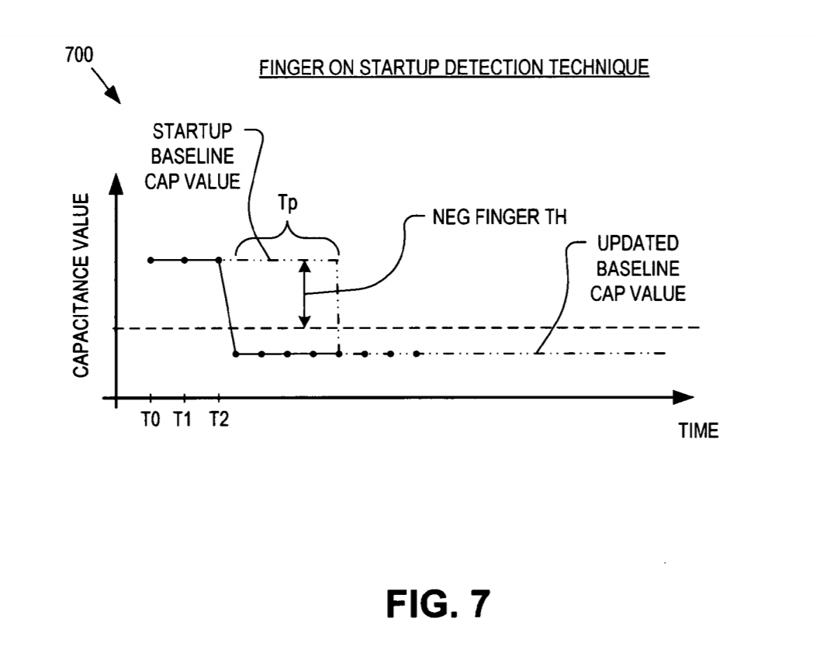

M.6 Why would you use the Activation with Hysteresis Technique work? How does it work?

Answer:

**Reason:** FIG. 8 is a chart 800 illustrating activation of CAP sensors 325 using hysteresis for improved capacitive touch sense operation, in accordance with an embodiment of the invention. **Depending on the scan rate of a capacitance sense interface 315, rapid repeat activation of the CAP sensors 325 may result in measured capacitance values that do not return all the way to the baseline capacitance value between activations. Unless compensated for, rapid repeat activations may not be detected.**

**Working: To compensate for rapid repeat activations, hysteresis logic 530 may add hysteresis to the detection algorithm by applying two separate thresholds for determining when a selected CAP sensor 325 is activated and when the selected CAP sensor 325 is deactivated.** As illustrated in FIG. 8, **hysteresis logic 530 may add an activation threshold and a lower deactivation threshold. When a measured capacitance value cross the activation threshold, the corresponding CAP sensor 325 is registered as “activated.” When the measured capacitance value falls below the deactivation threshold, the corresponding CAP sensor 325 is deemed “deactivated.” In this manner, the measured capacitance value need not return all the way to the baseline capacitance value before an activation is deemed deactivated, nor does the measured capacitance value need to return to the baseline capacitance value to register a subsequent activation.**

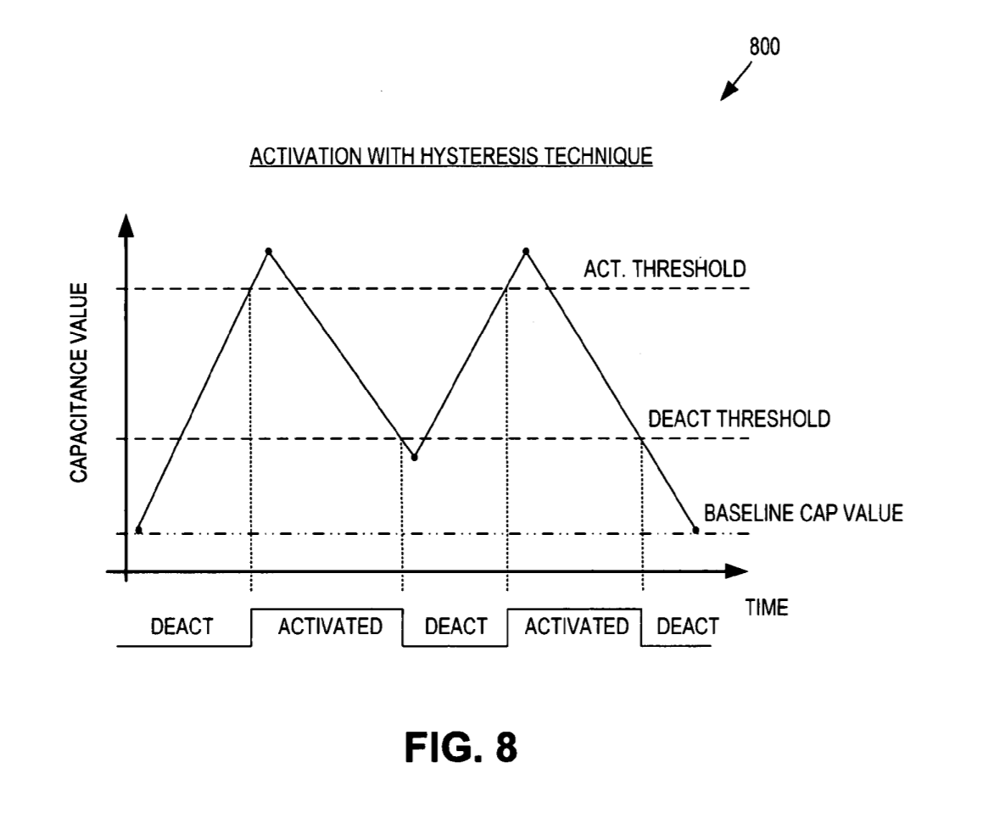

M.7 How does the ESD Compensation Technique determine whether a change in capacitance is from a finger touch or through ESD?

. Answer: FIG. 9A illustrates typical measured profiles for a finger event and an ESD event on CAP sensors 325, in accordance with an embodiment of the invention. As can be seen, the measured capacitance values rise and fall gradually as a user finger (or other conductive device) approaches and departs capacitance sense interface 315. **In contrast, an ESD event is typified by a rapid spike above the baseline capacitance value, followed by a rapid drop below the baseline capacitance value followed by a ringing or transients with rapidly declining envelope**.

FIG. 9B is a chart 900 illustrating an ESD compensation technique for rejecting ESD events, in accordance with an embodiment of the invention. The user interface environment has substantial opportunity for interruption from ESD events. In order to prevent false activation, signal 550 is evaluated by ESD logic 535. **The nature of ESD events is to inject large fast transients into the measured capacitance values, as illustrated in FIG. 9A. ESD logic 535 can reject these ESD events by quickly recognizing these transients and masking the false event for a period of time.**

**ESD logic 535 can recognize an ESD event by monitoring the slope between consecutive samplings of the measured capacitance values (e.g., calculating the derivative of traces S0 to S4 is real-time) and determining whether the measured capacitance values cross an ESD threshold below the baseline capacitance value. When the derivative value is significantly faster than typical of human activation, an activation may be rejected as an ESD event.** In one embodiment, ESD logic 535 determines that an ESD event has occurred **if: (1) the slope of the measured capacitance value turns positive and has a magnitude greater than a positive slope threshold (POS_SLOPE_TH), (2) the slope of the measured capacitance value then turns negative and has a magnitude greater than a negative slope threshold (NEG_SLOPE_TH), and (3) the measured capacitance value cross an ESD threshold (ESD_TH) below the baseline capacitance value. ESD logic 535 may apply a fourth requirement that conditions (1), (2), and (3) occur within a predetermined time threshold. If ESD logic 535 determines these conditions are valid, then the activation event is rejected as a false activation or ESD event and all activation on the particular CAP sensor 325 will be rejected or masked for a period of time.**

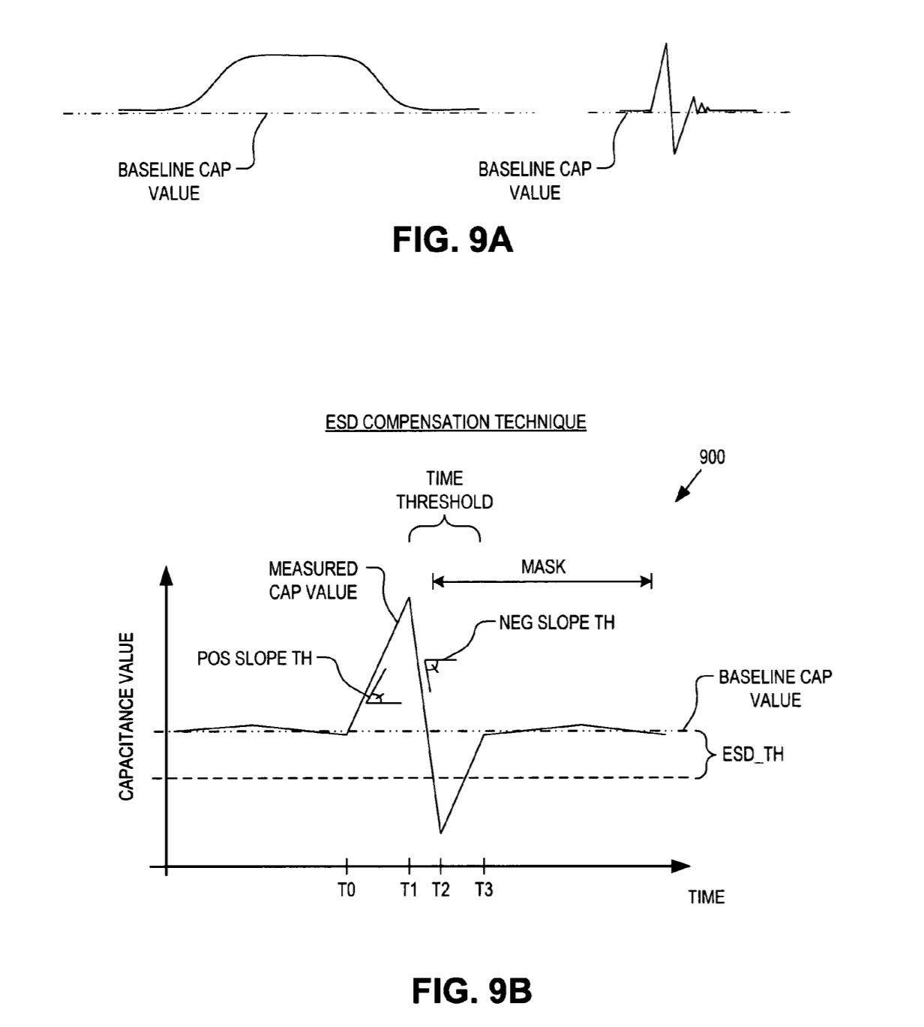

M.8 Why would you use Variable Resolution via Interpolation? How does this system work?

Answer: Some application logic 510 **may require the use of a sliding switch**, such as radial slider interface 320 or linear slider interface 330. In many cases **the resolution desired is much finer than is physically possible by simply using a greater number of smaller CAP sensors** 325. **There may also be a desire for detecting greater resolution or granularity than there are physical CAP sensors in the physical array of CAP sensors**. In one embodiment, interpolation logic 540 **includes detection algorithms to assess the signal strength on each CAP sensor in the array and map the measured values onto a user selected number of CAP sensors** (e.g., interpolation). Typical **examples include mapping eight linearly spaced CAP sensors 325 onto a 0 to 100 scale, mapping twenty CAP sensors 325 onto a 0 to 256 scale, or mapping eight CAP sensors 325 onto six separate capacitance sense buttons. The calculations may be done with fractional fixed point for efficiency in a limited capability microcontroller**.